CSE 581

**Lab 2: Basic Selects**

1. Select all data from the Order Details table.

SELECT *

FROM [Order Details]

2. Select all data from the Customers table, ordered by **ContactName**.

SELECT *

FROM Customers

ORDER BY ContactName

3. Select all data from the Orders table, ordered by OrderDate, oldest date on top.

SELECT *

FROM Orders

ORDER BY OrderDate ASC

4. Select all data from the Orders table, ordered by ShippedDate, newest date on top.

SELECT *

FROM Orders

ORDER BY ShippedDate DESC

5. Select all data from the Orders table, where order has not shipped yet (ShippedDate is null).

SELECT *

FROM Orders

WHERE ShippedDate IS NULL

6. Select CompanyName, ContactName and ContactTitle from the Customers table, where Company Name starts with D.

SELECT CompanyName, ContactName,ContactTitle

FROM Customers

WHERE CompanyName LIKE 'D%'

7. Select EmployeeID, FirstName, LastName and Title from the Employees table, where last name starts with D, E or F.

SELECT EmployeeID, FirstName, LastName

FROM Employees

WHERE LastName LIKE 'D%' OR LastName LIKE 'E%' OR LastName LIKE 'F%'

8. Select number of records from the Suppliers table. *=> Result should be a single cell containing a single number (however many digits is appropriate).*

SELECT *

FROM Suppliers

Answer:

29 rows of records

Screenshots:

1.

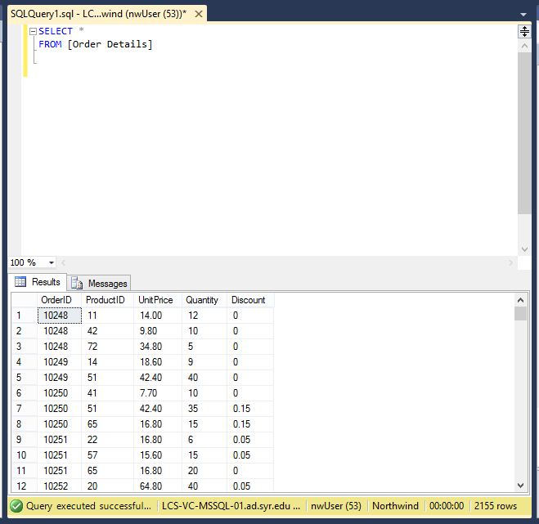

2.

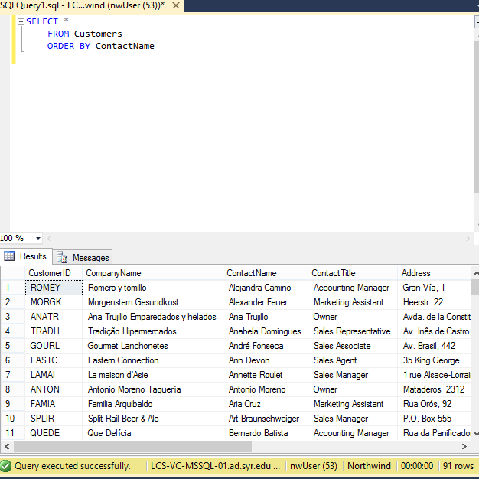

3.

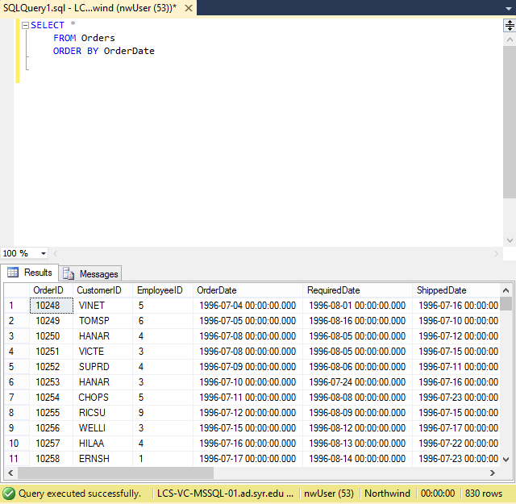

4.

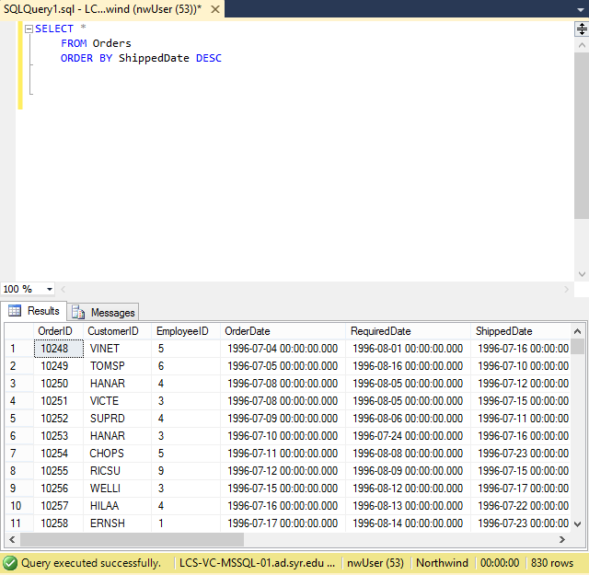

5.

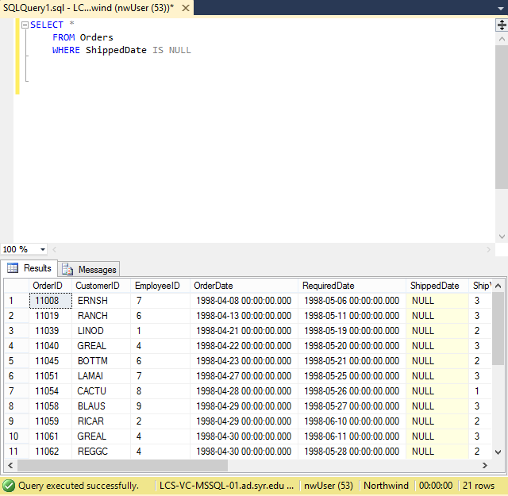

6.

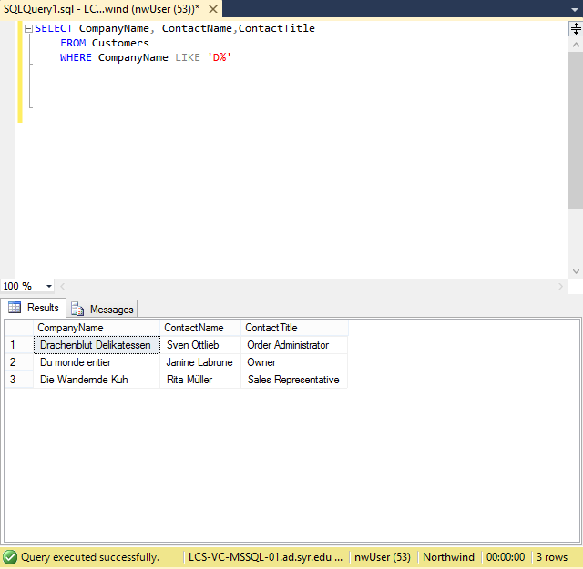

7.

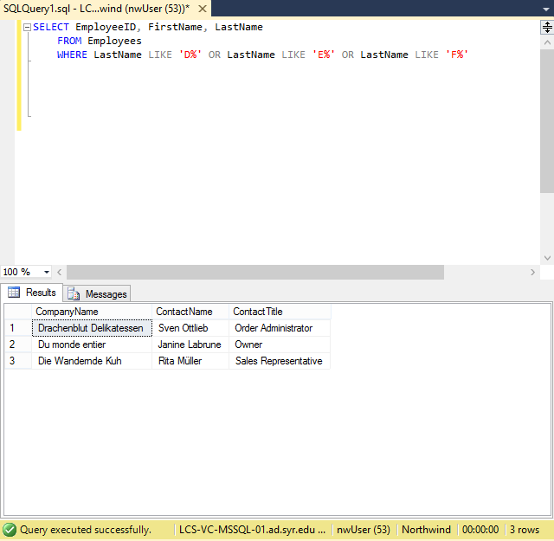

8.

